St Andrew's Church

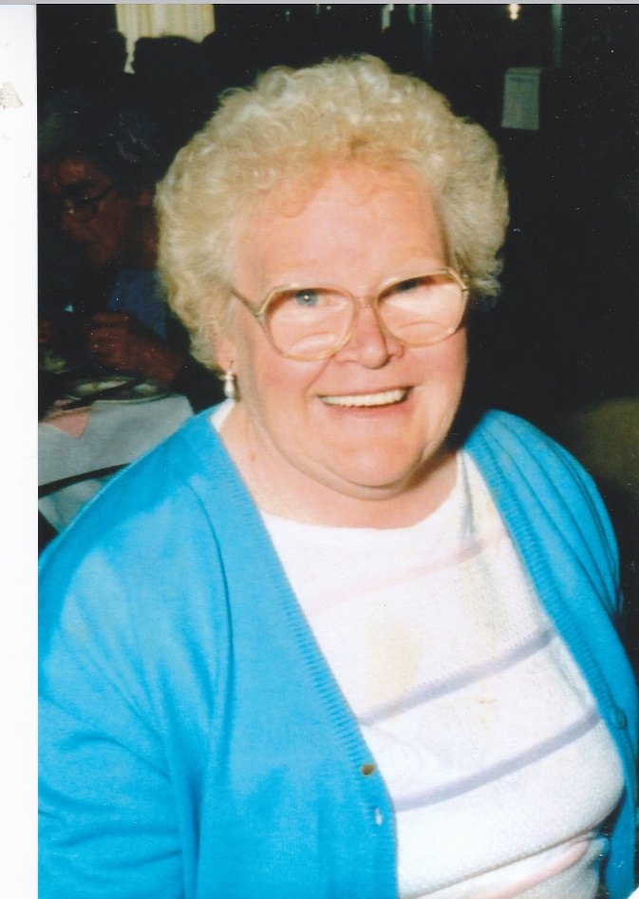Orford with Longford

Requiem for the soul of

Ehteline (Ett) Worrall

13th February 1925 to 17th February 2017

Thursday 9th March 2017